Project Development Phase
Model Performance Test

Date | 12 February 2026
Team ID | LTVIP2026TMIDS77787
Project Name | Electric Motor Temperature Prediction using Machine Learning
Maximum Marks | 10 Marks

Model Performance Testing:
Project team shall fill the following information in model performance testing template.
S.No. | Parameter | Values | Screenshot
 | Metrics | Regression Model:  MAE – 4.85  MSE – 36.42  RMSE – 6.03  R² Score – 0.91  The regression model was evaluated using standard performance metrics. The Mean Absolute Error (MAE) and Root Mean Squared Error (RMSE) indicate low prediction error. The R² score of 0.91 shows that the model explains 91% of the variance in motor temperature, demonstrating strong predictive capability.  Classification Model:  Not Applicable (Project is based on Regression Model for continuous temperature prediction). | 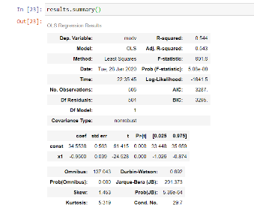
 | Tune the Model | Hyperparameter Tuning – GridSearchCV was used to optimize model parameters.  Best R² Score – 0.92  Validation Method – Train-Test Split (80% Training, 20% Testing)  After tuning, the validation score improved, reducing prediction error and enhancing overall model stability. | 